Microsoft Azure Data Explorer
The CEO's Account Was Hacked at 3AM
Assignment:
You are a SOC analyst working under Sarvesh, vCISO for Cloudazure, a 150-person B2B HR software company in London. At 08:55 this morning, Cloudora's IT admin flagged something strange: the CEO, Daniel Reeve, appears to have signed in from Lagos, Nigeria at 03:12 - while asleep in London. Cloudora is days from closing its biggest enterprise deal. If the CEO's mailbox is compromised, the deal, and the company's reputation, are on the line.
Your job: confirm or refute the compromise, establish the full timeline, find any persistence the attacker left behind, check whether anyone else was hit, and write the incident report your manager will take to the client.
Ticket | CLD-0001 - Suspicious sign-in activity: daniel.reeve@cloudazure.io
Priority | P1 - Executive account, active enterprise deal
Data provided | cloudora_signin_logs.csv (8 days of Entra ID sign-in logs), cloudora_audit_logs.csv (audit events)
Deliverable | Completed incident report using template CLD-IR-TEMPLATE (in this pack)
Skills built | KQL, Entra ID sign-in analysis, ATO investigation, MITRE ATT&CK; mapping, incident reporting

Investigation:
CSV File uploaded:
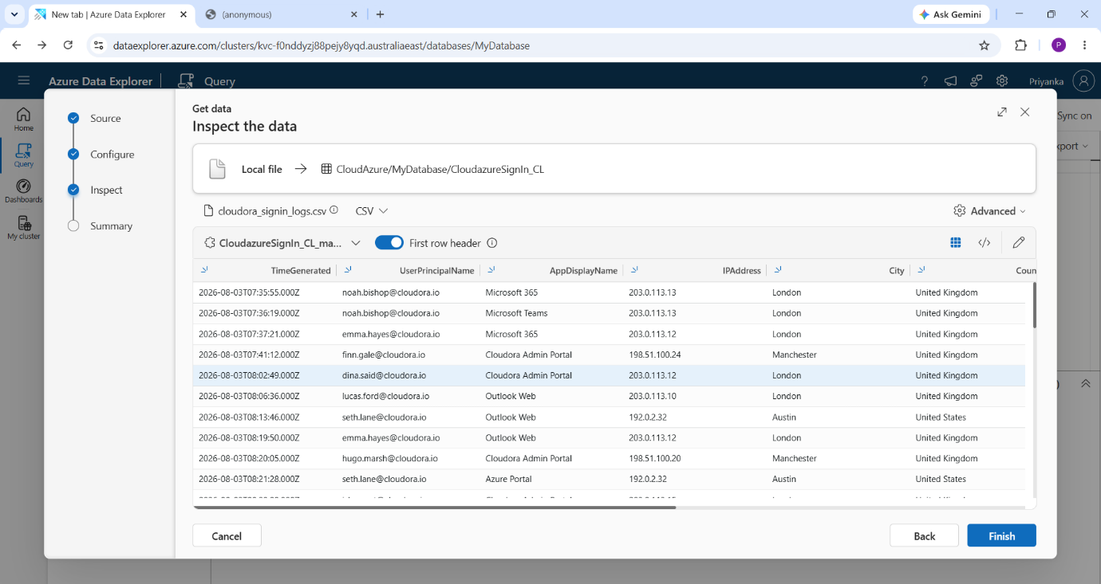

Total Count of data in file:
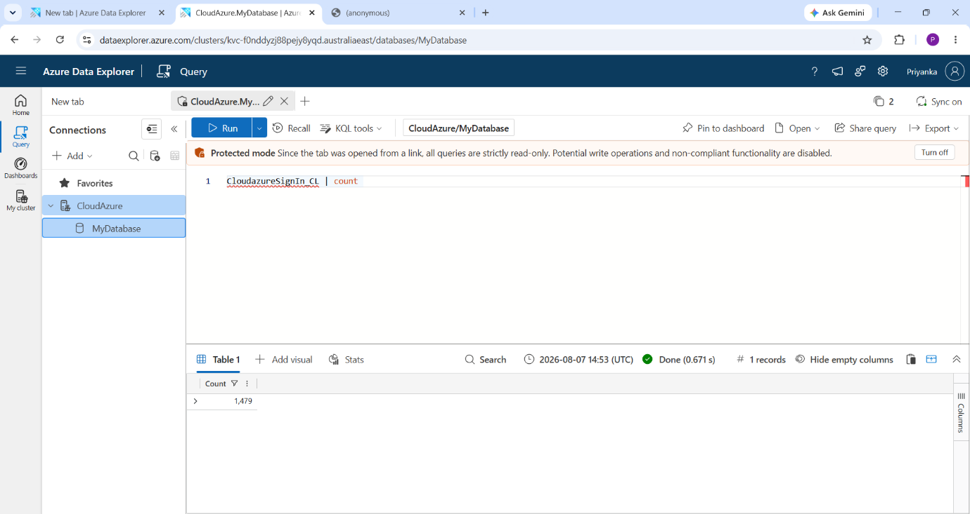

Step 1 - Triage the alert: is the Lagos sign-in real?
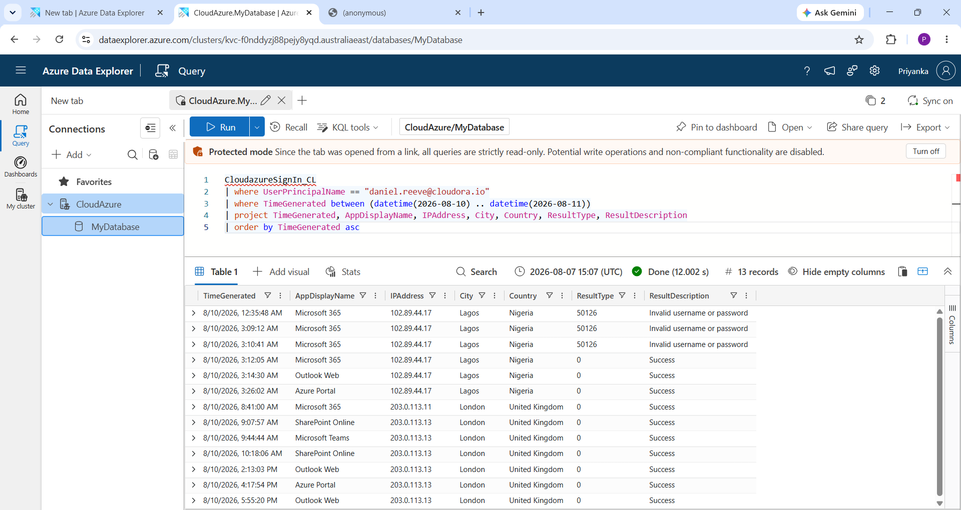

Step 2 - Rule out the innocent explanation
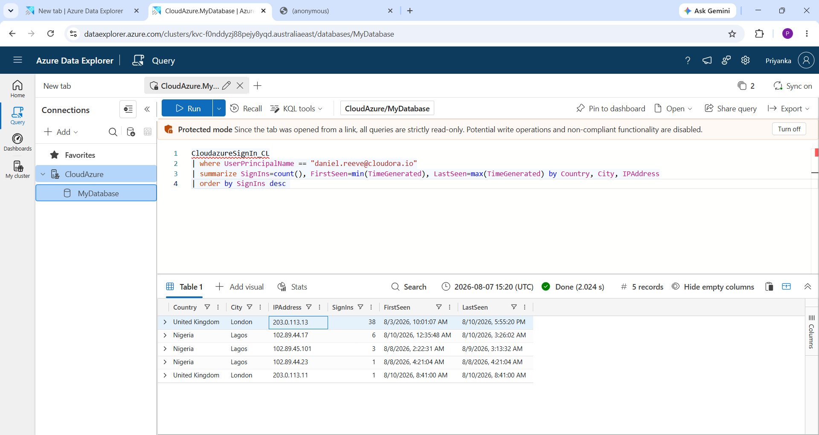

Step 3 - How did they get in? Find the attack that came first
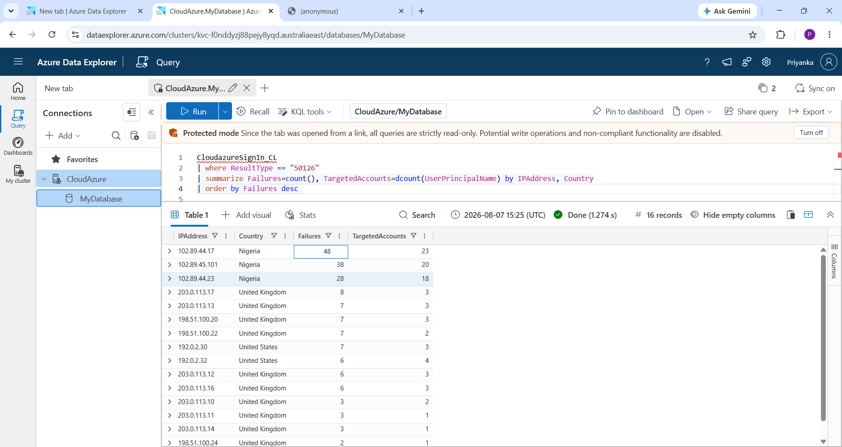

Step 4 - What did they do after getting in? Check for persistence
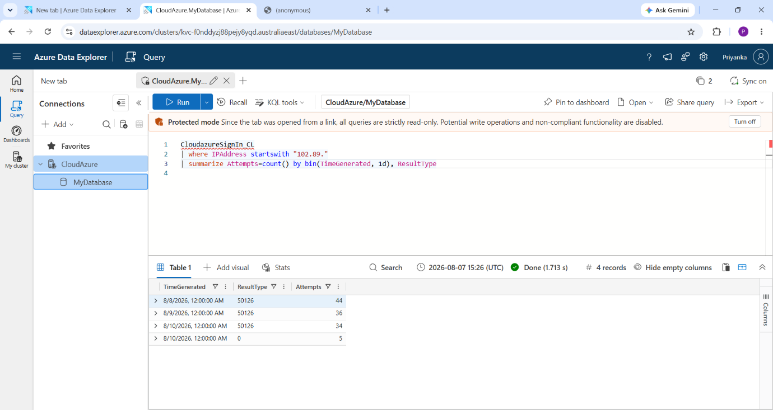
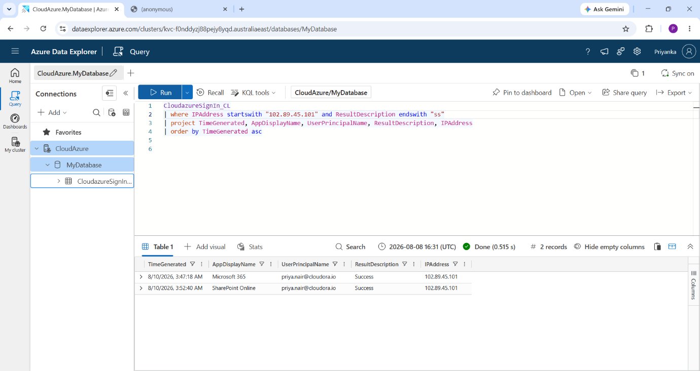

Step 5 - Scope it: is anyone else compromised?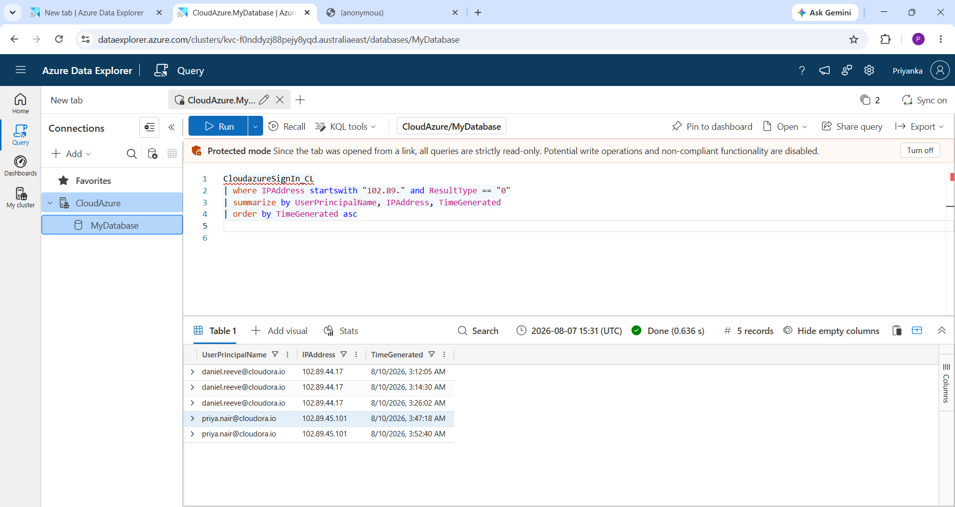

The second victim: priya.nair@cloudora.io
Move 1 - Timeline: what did the attacker do on this account?
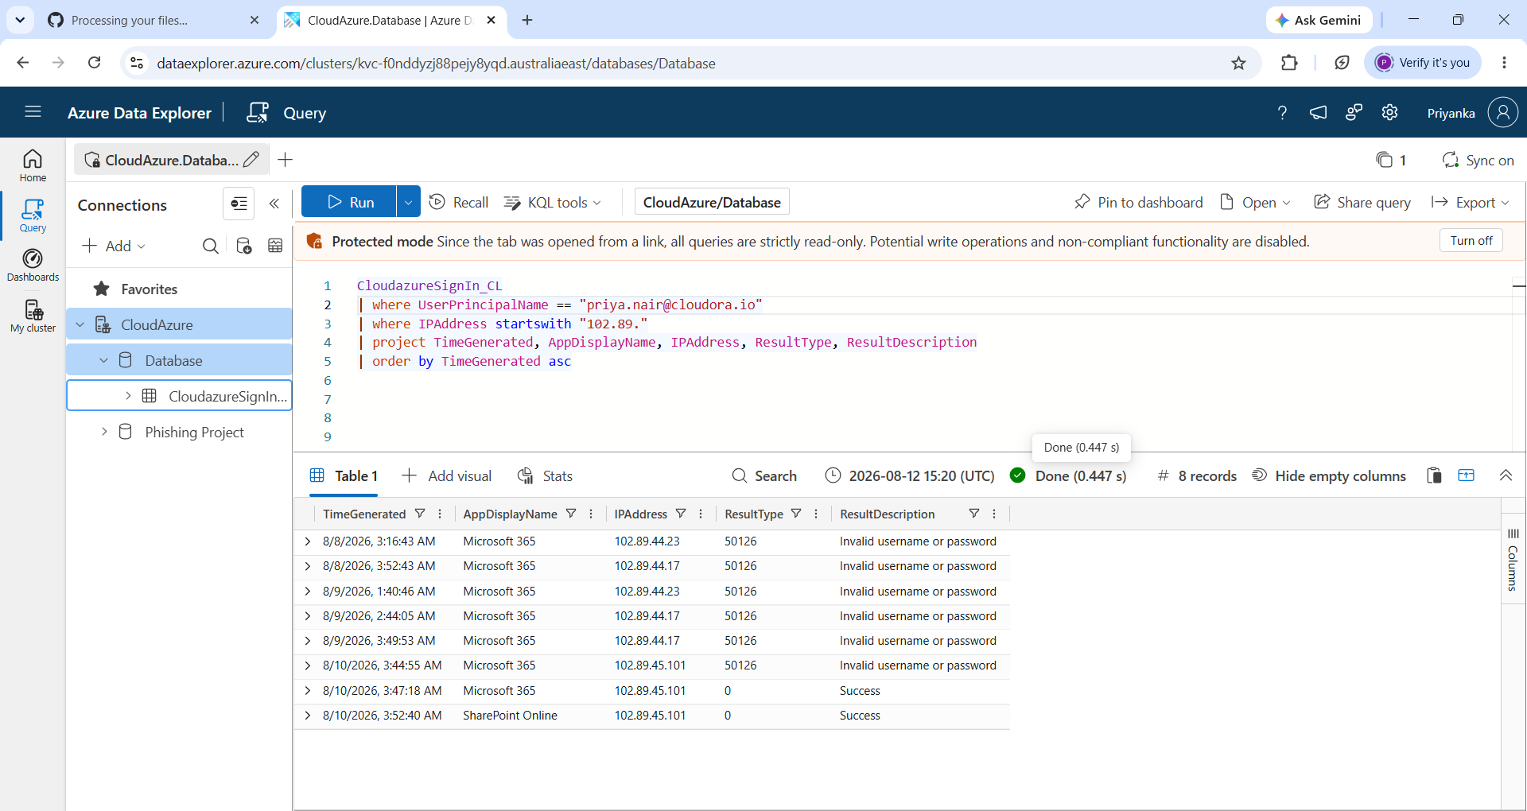

Move 2 - Baseline: is there an innocent explanation?
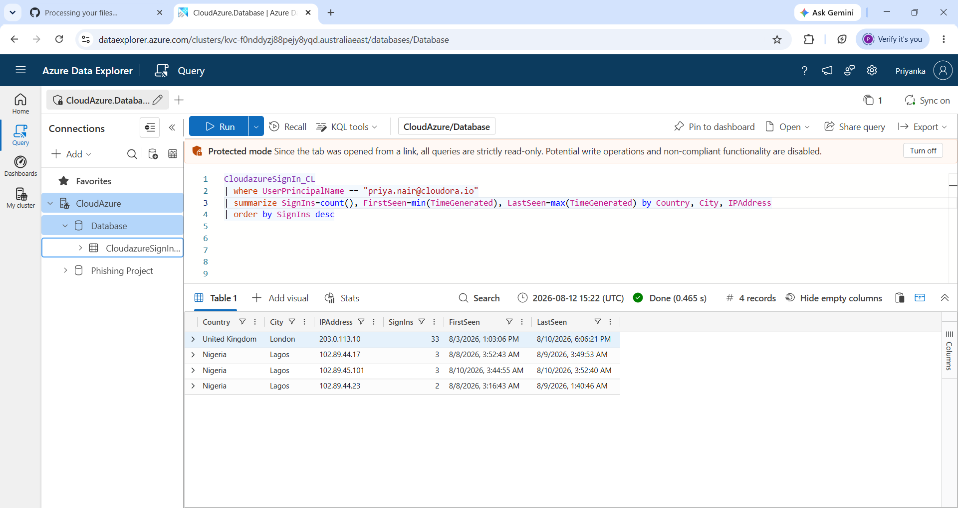
Scope: priya.nair moves from 'targeted' to 'confirmed compromised' (2 confirmed, 24 targeted-only). Timeline: add the 03:44 / 03:47 / 03:52 events. Findings: one new finding for the second compromise, noting SharePoint access and no observed persistence. Actions: same containment sequence as the CEO account.

